**Calculator Free**

**Applications of Differentiation**

Time: 45 minutes

Total Marks: 45

Your Score: / 45



**Question One: [8 marks]**

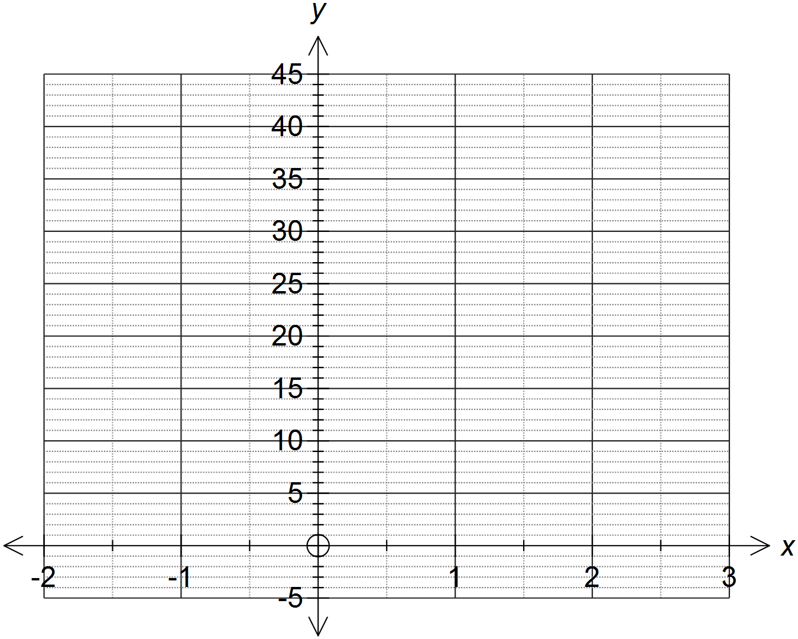Sketch the graph of  over the domain . Use calculus methods to determine the location and nature of any stationary points.

**Question Two: [1, 4, 3, 2, 3 = 13 marks]**

The displacement of a particle moving in rectilinear motion is modelled by  , where *t* is the time in seconds and *x* is the displacement in metres.

(a) Determine the initial displacement of the particle.

(b) Calculate the initial velocity of the particle and hence comment on the initial direction of the particle.

(c) Determine when the particle first changes direction.

(d) Determine the displacement of the particle when it changes direction for the second time. Comment on this result.

(e) Determine when the particle reaches maximum velocity and calculate the speed of the particle at this time.

**Question Three: [1, 1, 1, 2, 1, 1 = 7 marks]**

A radioactive substance decays continuously at a rate of 2%. The amount of radioactive material remaining can be modelled by the function  , where *A* is the amount of the substance in micrograms and *t* is the time in years.

1. State the value of *k* in this model.
2. Initially there are 20 micrograms of this substance. State the value of  .
3. How many micrograms of the substance are there after 20 years?
4. Give an expression for the average rate of change of the amount of radioactive material in the first 10 years.
5. Determine an expression for the instantaneous rate of change of the amount of the radioactive substance.
6. Calculate the instantaneous rate of change of the amount of substance after 100 years.

**Question Four: [1, 5 = 6 marks]**

Consider the function 

1. Calculate  .
2. Using your answer to (a) and the function  , calculate the approximate value of 

**Question Five: [2, 2, 2, 2, 3 = 11 marks]**

The current in a simple alternating current circuit is modelled by the function , where *t* is the time in seconds and *f* is the flow of current in amps.

1. Calculate the amps after 10 seconds.
2. State the maximum amp flow and the time(s) at which these occur in the first minute.
3. Determine an expression for the instantaneous rate of change of the current.
4. Calculate the instantaneous rate of change of the current at 30 seconds.
5. Approximate the change in the flow of current in the 41st second.

**SOLUTIONS**

**Calculator Free**

**Applications of Differentiation**

Time: 45 minutes

Total Marks: 45

Your Score: / 45



**Question One: [8 marks]**

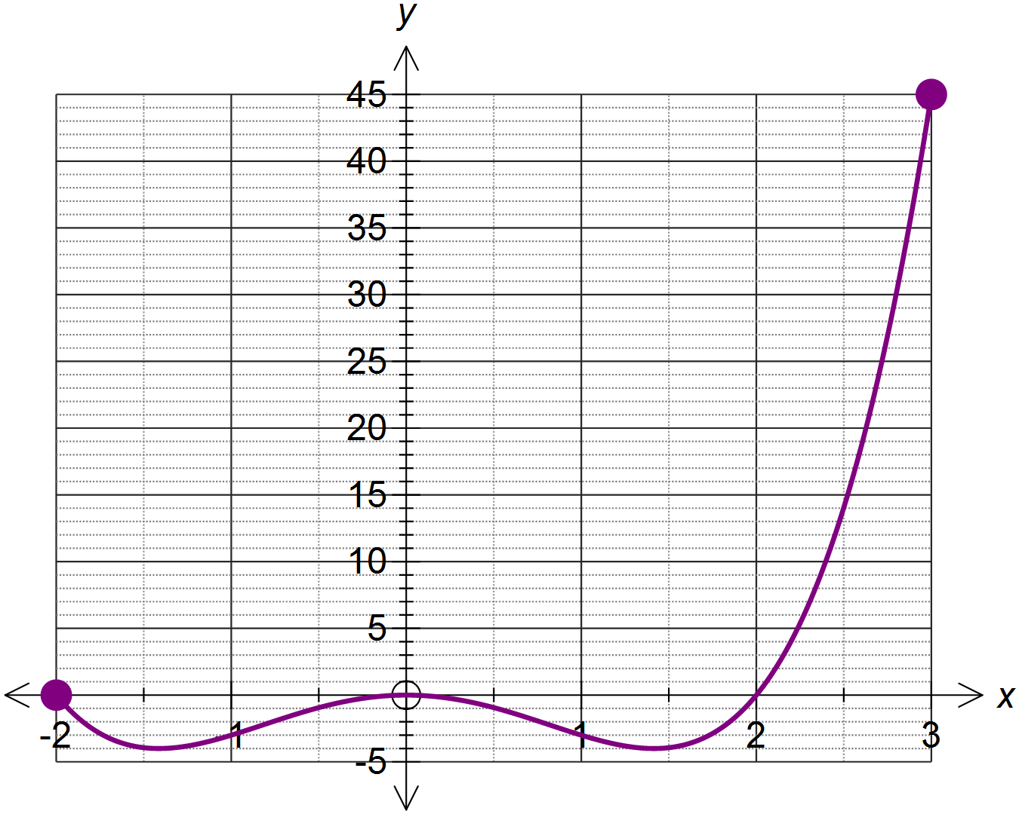Sketch the graph of  over the domain . Use calculus methods to determine the location and nature of any stationary points.



**Question Two: [1, 4, 3, 2, 3 = 13 marks]**

The displacement of a particle moving in rectilinear motion is modelled by  , where *t* is the time in seconds and *x* is the displacement in metres.

(a) Determine the initial displacement of the particle.



(b) Calculate the initial velocity of the particle and hence comment on the initial direction of the particle.

 

 Therefor the particle is initially directed towards the right of the origin.

(c) Determine when the particle first changes direction.

 

(d) Determine the displacement of the particle when it changes direction for the second time. Comment on this result.

 

When the particle changes direction for the second time it is located at the origin.



(e) Determine when the particle reaches maximum velocity and calculate the speed of the particle at this time.

 

**Question Three: [1, 1, 1, 2, 1, 1 = 7 marks]**

A radioactive substance decays continuously at a rate of 2%. The amount of radioactive material remaining can be modelled by the function  , where *A* is the amount of the substance in micrograms and *t* is the time in years.

1. State the value of *k* in this model.



1. Initially there are 20 micrograms of this substance. State the value of  .



1. How many grams of the substance are there after 20 years?



1. Give an expression for the average rate of change of the amount of radioactive material in the first 10 years.



1. Determine an expression for the instantaneous rate of change of the amount of the radioactive substance.



1. Calculate the instantaneous rate of change of the amount of substance after 100 years.



**Question Four: [1, 5 = 6 marks]**

Consider the function 

1. Calculate  .



1. Using your answer to (a) and the function  , calculate the approximate value of 



**Question Five: [2, 2, 2, 2, 3 = 11 marks]**

The current in a simple alternating current circuit is modelled by the function , where *t* is the time in seconds and *f* is the flow of current in amps.

1. Calculate the amps after 10 seconds.



1. State the maximum amp flow and the time(s) at which these occur in the first minute.

Maximum amp flow = 200 amps



1. Determine an expression for the instantaneous rate of change of the current.



1. Calculate the instantaneous rate of change of the current at 30 seconds.



1. Approximate the change in the flow of current in the 41st second.

 